5CS031 Network Security
Name : Aadarsha K.C.
Student id: np03cy4a240072/ 2513424

Workshop 1: Securing the Router for Administrative Access
Topology
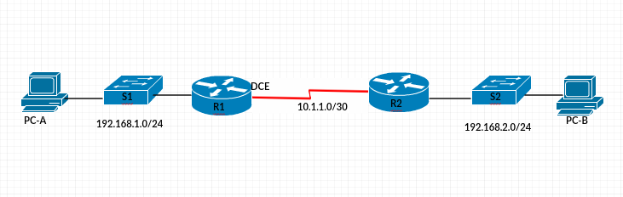
IP Addressing Table
Device | Interface | IP Address | Subnet Mask | Default Gateway
R1 | G0/0 | 192.168.1.1 | 255.255.255.0 | N/A
 | S0/0/0 (DCE) | 10.1.1.1 | 255.255.255.252 | N/A
R2 | S0/0/0 | 10.1.1.2 | 255.255.255.252 | N/A
 | G0/0 | 192.168.2.1 | 255.255.255.0 | N/A
PC-A | NIC | 192.168.1.2 | 255.255.255.0 | 192.168.1.1
PC-C | NIC | 192.168.2.2 | 255.255.255.0 | 192.168.2.1
Objectives
Part 1: Configure Basic Device Settings
- Cable the network as shown in the topology.
- Configure basic IP addressing for routers and PCs.
- Configure RIP routing.
- Configure PC hosts.
- Verify connectivity between hosts and routers.
Part 2: Control Administrative Access for Routers
- Configure and encrypt all passwords.
- Configure a login warning banner.
- Configure enhanced username password security.
- Configure an SSH server on a router.
- Configure an SSH client and verify connectivity.

Background / Scenario
The router is a critical component in any network. It controls the movement of data into and out of the network and between devices within the network. It is particularly important to protect network routers because the failure of a routing device could make sections of the network, or the entire network, inaccessible. Controlling access to routers and enabling reporting on routers is critical to network security and should be part of a comprehensive security policy.
In this workshop, you will build a multi-router network and configure the routers and hosts. Use various CLI tools to secure local and remote access to the routers, analyze potential vulnerabilities, and take steps to mitigate them.
Note: Before you begin, ensure that the routers and the switches have been erased and have no startup configurations.

- Configure Basic Device Settings
In Part 1, set up the network topology and configure basic settings, such as interface IP addresses.
    - Cable the network.
Attach the devices, as shown in the topology diagram, and cable as necessary.
    - Configure basic settings for each router.
      - Configure host names as shown in the topology.
      - Configure interface IP addresses as shown in the IP Addressing Table.
      - Configure a clock rate for router with a DCE serial cable attached to their serial interface. R1 is shown here as an example.
R1(config)# interface S0/0/0
R1(config-if)# clock rate 64000
      - To prevent the router from attempting to translate incorrectly entered commands as though they were host names, disable DNS lookup. R1 is shown here as an example.
R1(config)# no ip domain-lookup
    - Configure RIP routing on the routers.
      - Use the router RIP command in global configuration mode to enable RIP on R1.
R1(config)# router RIP
      - Configure the network statements for the networks on R1.
R1(config-router)# network 192.168.1.0
R1(config-router)# network 10.1.1.0
      - Configure the hostname, IP addresses and RIP on R2.

    - Verify routing information.
      - Issue the show ip route command to verify that all networks display in the routing table on all routers.
R1# show ip route

    - Configure PC host IP settings.
Configure a static IP address, subnet mask, and default gateway for PC-A and PC-B as shown in the IP Addressing Table.
    - Verify connectivity between PC-A and PC-B.
      - Ping from R1 to R2.
If the pings are not successful, troubleshoot the basic device configurations before continuing.
      - Ping from PC-A, on the R1 LAN, to PC-B, on the R2 LAN.
If the pings are not successful, troubleshoot the basic device configurations before continuing.
Note: If you can ping from PC-A to PC-B you have demonstrated that RIP routing is configured and functioning correctly. If you cannot ping but the device interfaces are up and IP addresses are correct, use the show run, show ip route commands to help identify routing protocol-related problems.

You need to complete this step before proceeding with part 2
- Control Administrative Access for Routers
In Part 2, you will:
- Configure and encrypt passwords.
- Configure a login warning banner.
- Configure enhanced username password security.
- Configure enhanced virtual login security.
- Configure an SSH server on R1.
- Research terminal emulation client software and configure the SSH client.
Note: Perform all tasks on both R1 and R2. The procedures and output for R1 are shown here.
  - Configure and Encrypt Passwords on Routers R1 and R2.
    - Configure a minimum password length for all router passwords.
Use the security passwords command to set a minimum password length of 10 characters.
R1(config)# security passwords min-length 10
    - Configure the enable secret password.
Configure the enable secret encrypted password on both routers.
R1(config)# enable secret cisco12345
How does configuring an enable secret password help protect a router from being compromised by an attack?
ANS:
Configuring an enable secret password protects a router by requiring a secure password to access privileged mode, where important configuration changes can be made. The password is encrypted, which prevents attackers from easily reading or stealing it, helping keep the router safe from unauthorized access.
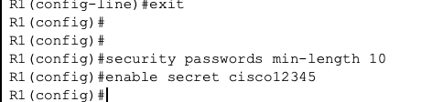
_________________________________________________________________

    - Configure basic console and virtual access lines.
Note: Passwords in this task are set to a minimum of 10 characters but are relatively simple for the benefit of performing the lab. More complex passwords are recommended in a production network.
      - Configure a console password and enable login for routers. For additional security, the exec-timeout command causes the line to log out after 5 minutes of inactivity. The logging synchronous command prevents console messages from interrupting command entry.
Note: To avoid repetitive logins during this lab, the exec-timeout command can be set to 0 0, which prevents it from expiring. However, this is not considered a good security practice.
R1(config)# line console 0
R1(config-line)# password ciscocon
R1(config-line)# exec-timeout 5 0
R1(config-line)# login
R1(config-line)# logging synchronous
When you configured the password for the console line, what message was displayed?

ANS:
When I configured the password for the console line, “Password too short – must be at least 10 characters. Password not configured “ message was displayed as seen in below screenshot.
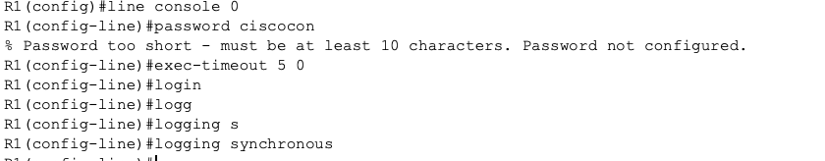
_________________________________________________________________

      - Configure a new password of ciscoconpass for the console.

      - Telnet from R2 to R1.
R2> telnet 10.1.1.1
Were you able to login? Explain.
ANS:
No, I wasn’t able to login because the VTY lines on R1 have not yet been configured with password, which is required by default or Telnet access.
_________________________________________________________________

What messages were displayed?
ANS:
Connection to 10.1.1.1 closed by foreign host messages were displayed.

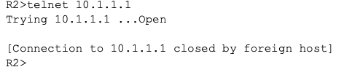
_________________________________________________________________

      - Configure the password on the virtual access lines (vty lines) for router R1 to allow remote access
R1(config)# line vty 0 4
R1(config-line)# password ciscovtypass
R1(config-line)# exec-timeout 5 0
R1(config-line)# transport input telnet
R1(config-line)# login

Telnet from R2 to R1 again. Were you able to login this time?
ANS:
Yes, I was able to login this time.
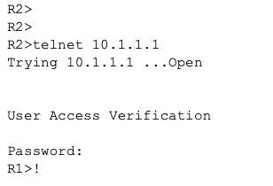
_________________________________________________________________

____________________________________________________________________________________
      - Enter privileged EXEC mode and issue the show run command. Can you read the enable secret password? Explain.
ANS:
No, I cannot read the enable secret password as it appears to be random strings which seems to be strongly hashed/encrypted by the router by default.
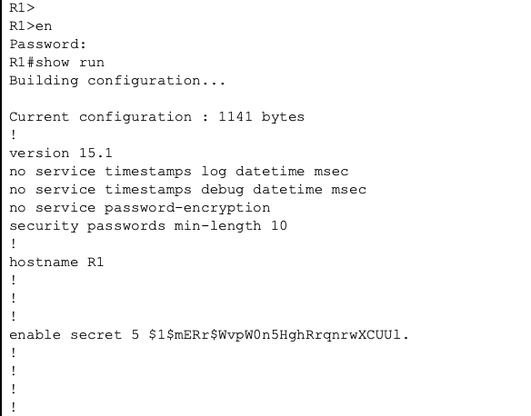
_________________________________________________________________

Can you read the console, aux, and vty passwords? Explain.
ANS:
Yes, I can easily read the console, aux, and vty passwords because we haven’t configured router so that it encrypts these passwords just like secret password so it shows the passwords in plain text in running config of the router. But we can do that by command “service password-encryption”.
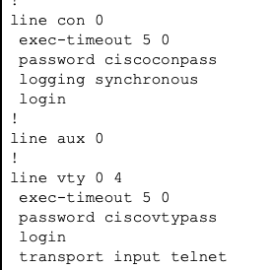
_________________________________________________________________

      - Repeat the configuration portion of steps 3a through 3f on router R2.
    - Encrypt clear text passwords.
      - Use the service password-encryption command to encrypt the console, aux, and vty passwords.
R1(config)# service password-encryption
      - Issue the show run command. Can you read the consoleand vty passwords? Explain.
ANS:
No, I can’t read the console and vty passwords because by using command service password-encryption, those passwords are encrypted by router by default and make the password into random strings.
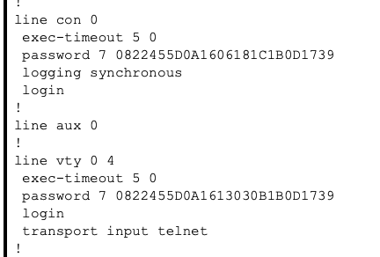
_________________________________________________________________

At what level (number) is the default enable secret password encrypted?
ANS: At level 5 is the default enable password encrypted since MD5 on standard Packet Tracer router.
At what level (number) are the other passwords encrypted?
ANS: At level 7 are the other password encrypted since Cisco’s proprietary Type 7 encryption.

Which level of encryption is harder to crack and why?
ANS: Level 5 (enable secret) level of encryption is much harder to crack. Level 7 uses a weak reversable algorithm that can easily be decrypted by using online tools. Whereas level 5 uses a one-way mathematical hashing method (MD5), which can’t be easily reversed, only brute-forced.

  - Configure a Login Warning Banner on Routers R1 and R2.
    - Configure a warning message to display prior to login.
      - Configure a warning to unauthorized users with a message-of-the-day (MOTD) banner using the banner motd command. When a user connects to one of the routers, the MOTD banner appears before the login prompt. In this example, the dollar sign ($) is used to start and end the message.
R1(config)# banner motd $Only YOURNAME permitted!$
R1(config)# exit
      - Issue the show run command. What does the $ convert to in the output?
ANS: The $convert to ^C in the output.
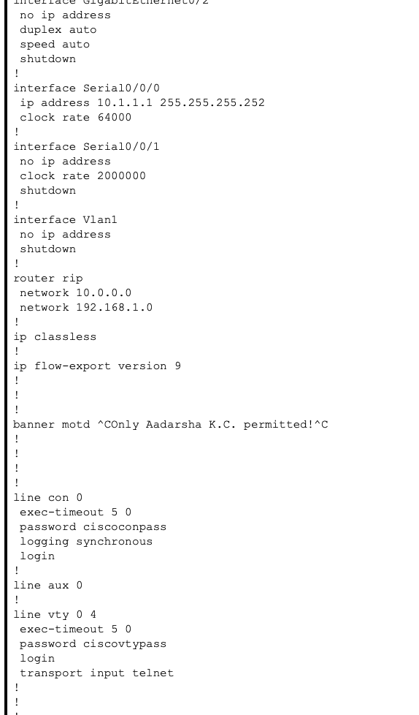
  - Configure Enhanced Username Password Security on Routers R1 and R2.
    - Create a new user account with a secret password.
      - Create a new user account with an encrypted password.
R1(config)# username user01 secret user01pass
      - Exit global configuration mode and save your configuration.
      - Display the running configuration.
ANS:
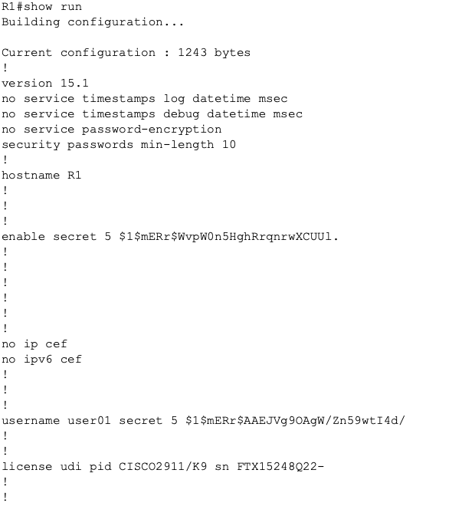
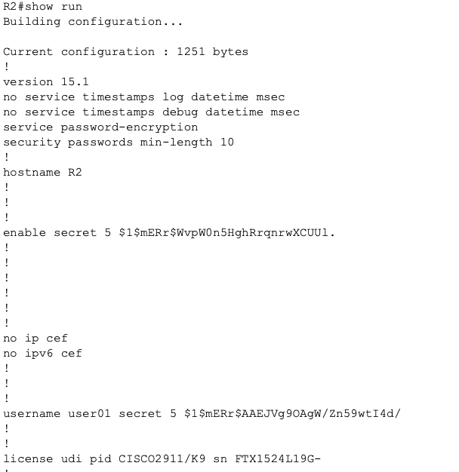

    - Test the new account by logging in to the console.
      - Set the console line to use the locally defined login accounts.
R1(config)# line console 0
R1(config-line)# login local
R1(config-line)# end
R1# exit
      - Exit to the initial router screen which displays: R1 con0 is now available, Press RETURN to get started.
      - Log in using the previously defined username user01 and the password user01pass.
What is the difference between logging in at the console now and previously?
ANS:
The difference between logging in at the console now and preciously is Previously, the console only prompted for single password which is single line authentication whereas now it prompts both username and password and verify credentials from router’s local user database.
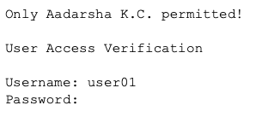

      - After logging in, issue the show run command. Were you able to issue the command? Explain.
ANS:
No, I wasn’t able to issue command because issuing that command requires privileged EXEC mode. But I created user01 account without specifying privilege level, and it sets it privilege to its default user privilege which doesn’t have permission to view the configuration.
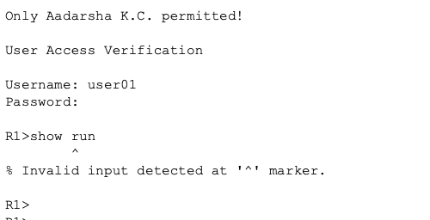

      - Enter privileged EXEC mode using the enable command. Were you prompted for a password? Explain.
ANS:
Yes, I was prompted for a password because user01 doesn’t have the EXEC privilege so we must provide enable secret password (cisco12345) to elevate our privilege or access level.
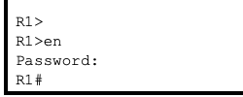
    - Test the new account by logging in from a Telnet session.
      - Open “Desktop” and Telnet/SSH Client and choose “Telnet”.
      - Input the R1 G0/0 IP address 192.168.1.1 in the Host Name (or IP address) field.
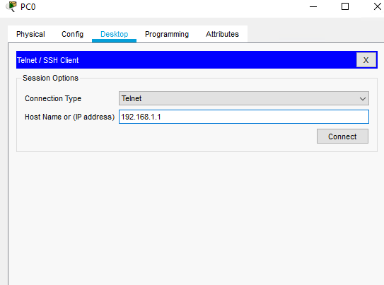

Were you prompted for a user account? Explain.
ANS: No, I wasn’t prompted for a user account. It only prompted password because VTY lines are still configured with basic login command which only checks line password and doesn’t check the local user database.
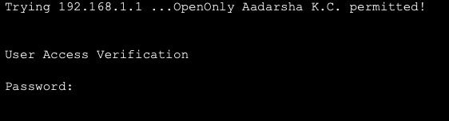

      - Set the vty lines to use the locally defined login accounts.
R1(config)# line vty 0 4
R1(config-line)# login local
      - From PC-A, telnet to R1 again.
Were you prompted for a user account? Explain.
ANS: Yes I was prompted for a user account because in above c we have configured line vty for login local which enables it to prompt for username and password and verify it from local user database.

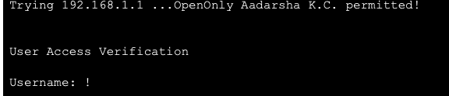

      - Log in as user01 with a password of user01pass.
      - During the Telnet session to R1, access privileged EXEC mode with the enable command.
What password did you use?
ANS: During the Telnet session to R1,to access privileged EXEC mode with enable command, I used the password cisco12345.
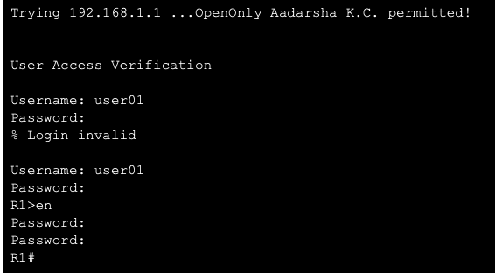

  - Configure the SSH Server on Router R1 and R2.
In this task, use the CLI to configure the router to be managed securely using SSH instead of Telnet. Secure Shell (SSH) is a network protocol that establishes a secure terminal emulation connection to a router or other networking device. SSH encrypts all information that passes over the network link and provides authentication of the remote computer. SSH is rapidly replacing Telnet as the remote login tool of choice for network professionals.
Note: For a router to support SSH, it must be configured with local authentication, (AAA services, or username) or password authentication. In this task, you configure an SSH username and local authentication.
    - Configure a domain name.
Enter global configuration mode and set the domain name.
R1# conf t
R1(config)# ip domain-name networksecurity.com
    - Configure a privileged user for login from the SSH client.
      - Use the username command to create the user ID with the highest possible privilege level and a secret password.
R1(config)# username admin privilege 15 secret cisco12345

      - Exit to the initial router login screen. Log in with the username admin and the associated password. What was the router prompt after you entered the password?
ANS: The router prompt after I entered the password was R1# .

    - Configure the incoming vty lines.
Specify a privilege level of 15 so that a user with the highest privilege level (15) will default to privileged EXEC mode when accessing the vty lines. Other users will default to user EXEC mode. Use the local user accounts for mandatory login and validation and accept only SSH connections.
R1(config)# line vty 0 4
R1(config-line)# privilege level 15
R1(config-line)# login local
R1(config-line)# transport input ssh
R1(config-line)# exit
Note: The login local command should have been configured in a previous step. It is included here to provide all commands, if you are doing this for the first time.
Note: If you add the keyword telnet to the transport input command, users can log in using Telnet as well as SSH, however, the router will be less secure. If only SSH is specified, the connecting host must have an SSH client installed.
    - Erase existing key pairs on the router.
R1(config)# crypto key zeroize rsa
Note: If no keys exist, you might receive this message: % No Signature RSA Keys found in configuration.
    - Generate the RSA encryption key pair for the router.
The router uses the RSA key pair for authentication and encryption of transmitted SSH data.
    - Configure the RSA keys with 1024 for the number of modulus bits. The default is 512, and the range is from 360 to 2048.
R1(config)# crypto key generate rsa general-keys modulus 1024
The name for the keys will be: R1.networksecurity.com

% The key modulus size is 1024 bits
% Generating 1024 bit RSA keys, keys will be non-exportable...[OK]

R1(config)#
*Dec 16 21:24:16.175: %SSH-5-ENABLED: SSH 1.99 has been enabled
      - Issue the ip ssh version 2 command to force the use of SSH version 2.
R1(config)# ip ssh version 2
R1(config)# exit

    - Verify the SSH configuration.
      - Use the show ip ssh command to see the current settings.
R1# show ip ssh
      - Fill in the following information based on the output of the show ip ssh command.
SSH version enabled: Version 2.0
Authentication timeout: 120 secs
Authentication retries: 3
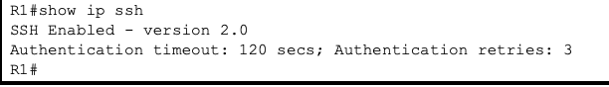
    - Configure SSH timeouts and authentication parameters.
The default SSH timeouts and authentication parameters can be altered to be more restrictive using the following commands.
R1(config)# ip ssh time-out 90
R1(config)# ip ssh authentication-retries 2

  - Configure the SSH Client.

    - Verify SSH connectivity to R1 from PC-A.
      - Launch “Telnet/SSH Client” from Desktop.
      - Input the R1 G0/0 IP address 192.168.1.1 in the Host Name (or IP address) field.

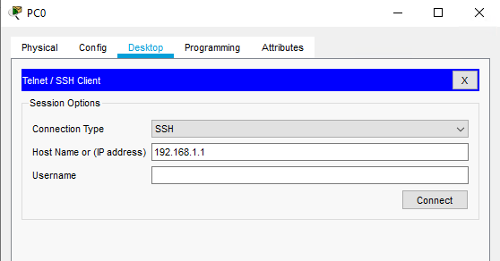

      - Enter the admin username and password cisco12345 when prompted
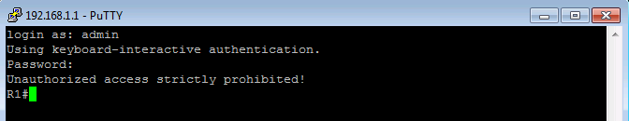
      - At the R1 privileged EXEC prompt, enter the show users command.
R1# show users
What users are connected to router R1 at this time?
ANS: The users that are connected to router R1 at this time is admin.

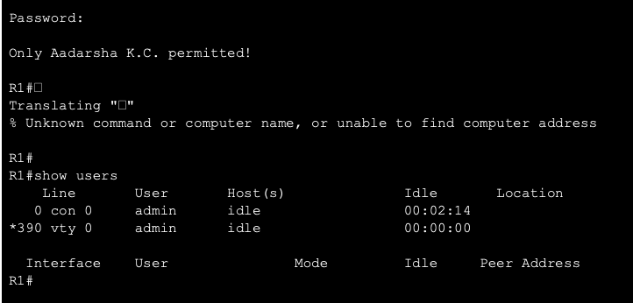

      - Try to open a Telnet session to your router from PC-A. Were you able to open the Telnet session? Explain.
ANS: No, I wasn’t able to open the telnet session because we applied transport input ssh command to VTY lines. This restricts remote management to SSH only, securing router by blocking unencrypted telnet traffic.

      - Open a SSH session to the router from PC-A. Enter the user01 username and password user01pass in the SSH window to try connecting for a user who does not have privilege level of 15.
If you were able to login, what was the prompt?
ANS: I was able to login using username user01 and password user01pass and the prompt was R1> .

      - Use the enable command to enter privilege EXEC mode and enter the enable secret password cisco12345.

